Straight-Line Generator

Definition
# Source: AI Source: Provided by: [Data Path: Persons Table -> ID Column: 1, Name_En Column: Motasem Essam] -> From: [ChatGPT] on [7/25/2026]
A Straight-Line Generator (also called a Linear Generator, Generating Line, or Rectilinear Generatrix) is a straight line that moves through three-dimensional space according to a specified geometric rule to generate a surface.
Each position occupied by the moving line forms a straight-line element of the generated surface. A surface formed by a continuous family of straight-line generators is called a Ruled Surface.
Straight-line generators are fundamental in constructing cylindrical surfaces, conical surfaces, and other ruled surfaces.

Geometric Representation
# Source: AI Source: Provided by: [Data Path: Persons Table -> ID Column: 1, Name_En Column: Motasem Essam] -> From: [ChatGPT] on [7/25/2026]
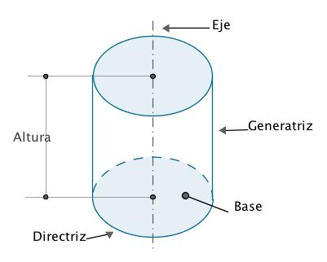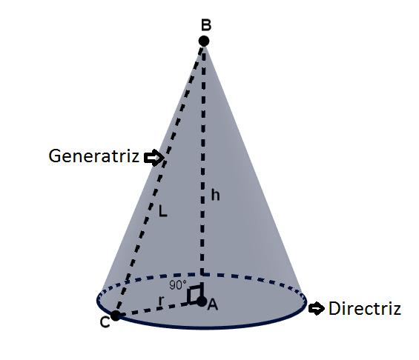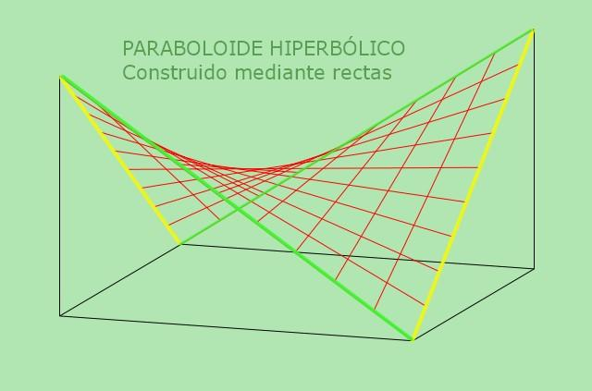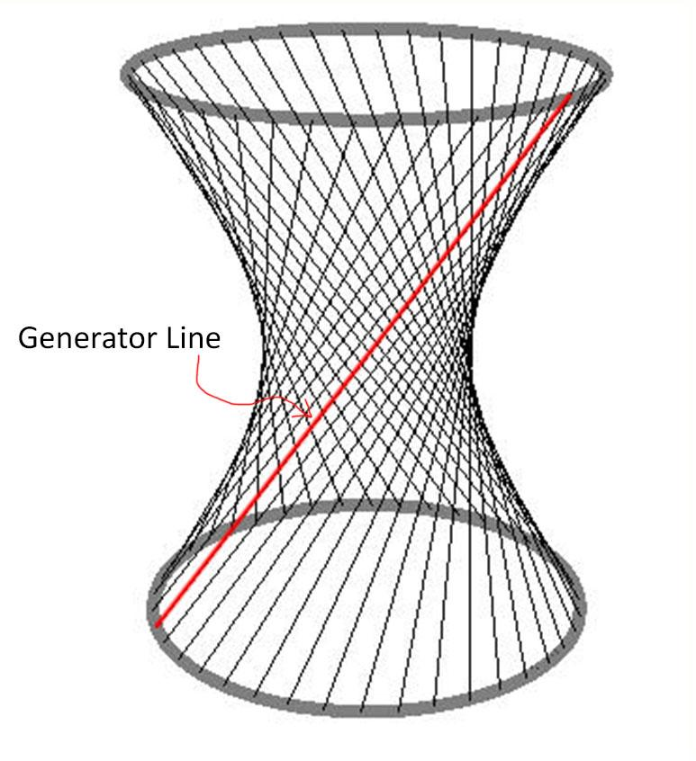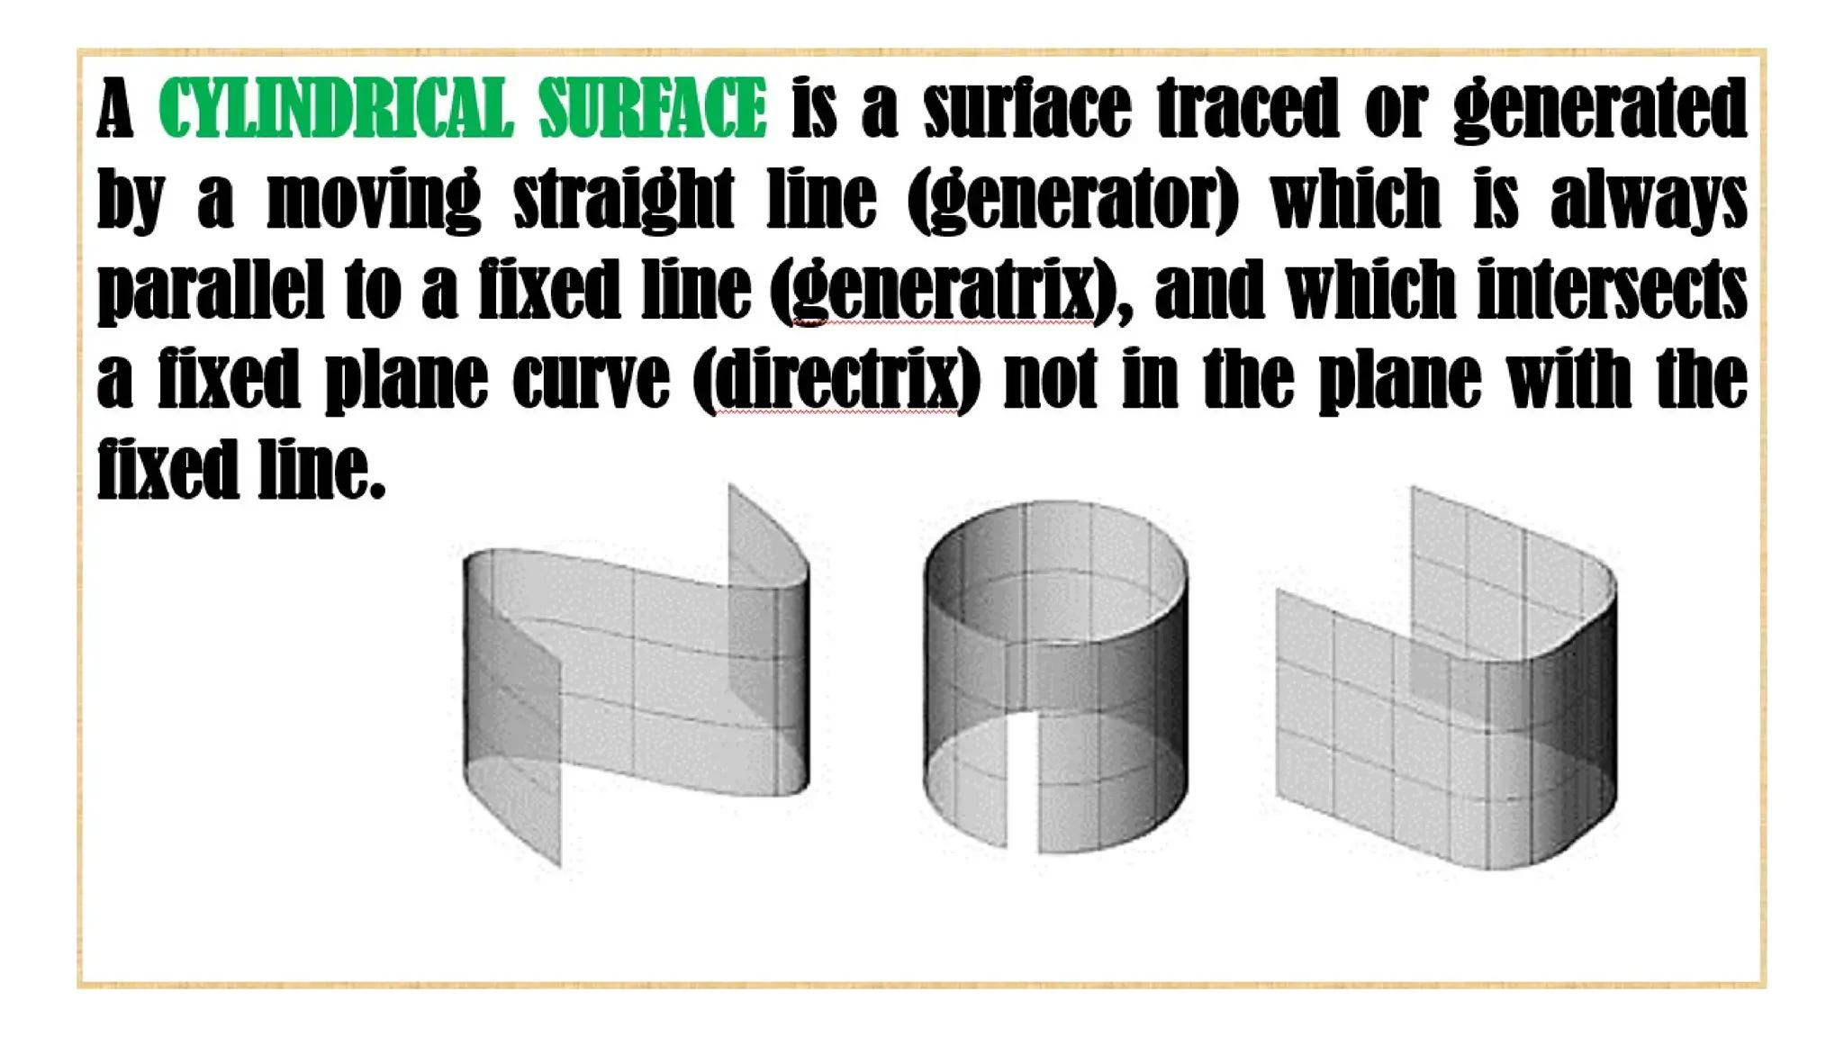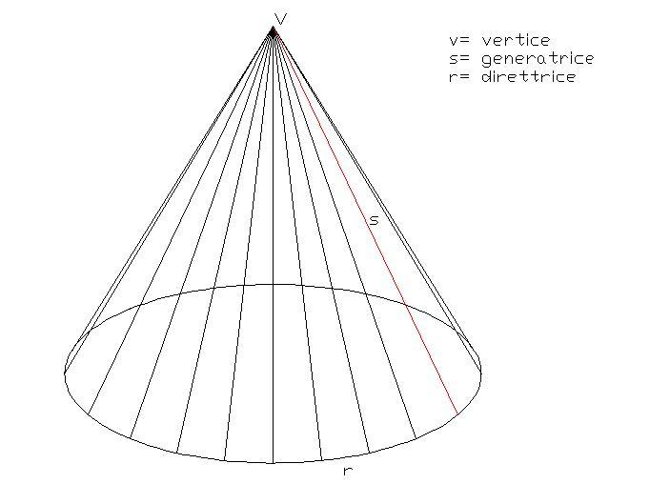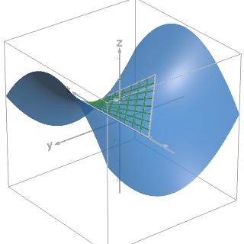

Geometric Structure
# Source: AI Source: Provided by: [Data Path: Persons Table -> ID Column: 1, Name_En Column: Motasem Essam] -> From: [ChatGPT] on [7/25/2026]
A straight-line generator has the following geometric characteristics:
- Straight-Line Form: The generating element is a straight line.
- Continuous Motion: It changes position according to a defined geometric rule.
- Generating Direction: Its direction may remain constant or change during movement.
- Directrix Relationship: It may intersect, follow, or be determined by a guiding curve.
- Surface Formation: The collection of its successive positions forms a ruled surface.
- Generator Element: Each individual position of the moving line is a straight-line element of the generated surface.

Fundamental Elements
# Source: AI Source: Provided by: [Data Path: Persons Table -> ID Column: 1, Name_En Column: Motasem Essam] -> From: [ChatGPT] on [7/25/2026]
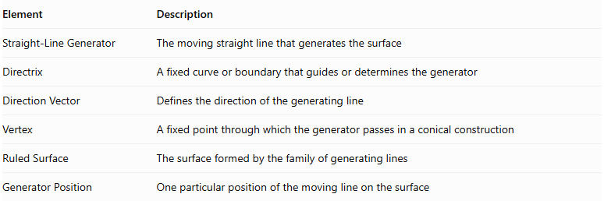
Element | Description
Straight-Line Generator | The moving straight line that generates the surface
Directrix | A fixed curve or boundary that guides or determines the generator
Direction Vector | Defines the direction of the generating line
Vertex | A fixed point through which the generator passes in a conical construction
Ruled Surface | The surface formed by the family of generating lines
Generator Position | One particular position of the moving line on the surface

Types of Straight-Line Generators

Cylindrical Straight-Line Generator
# Source: AI Source: Provided by: [Data Path: Persons Table -> ID Column: 1, Name_En Column: Motasem Essam] -> From: [ChatGPT] on [7/25/2026]
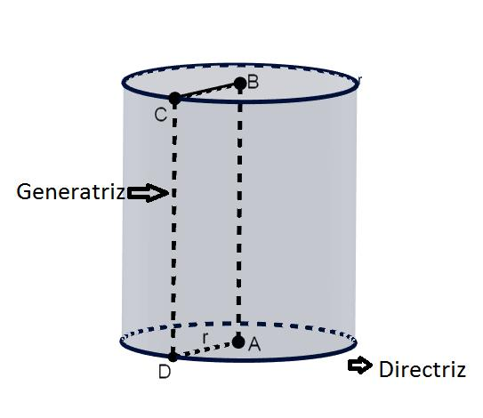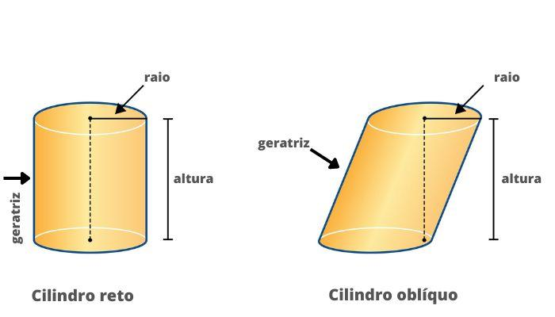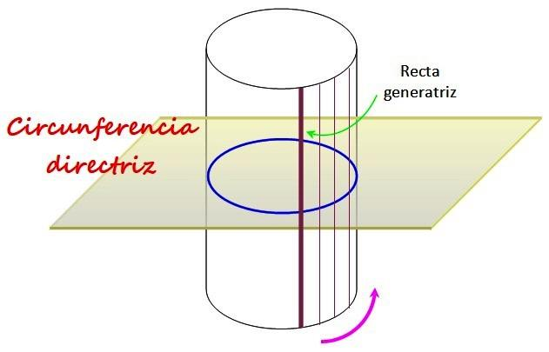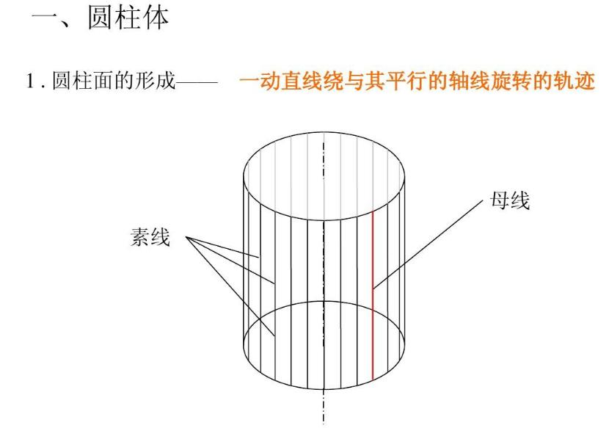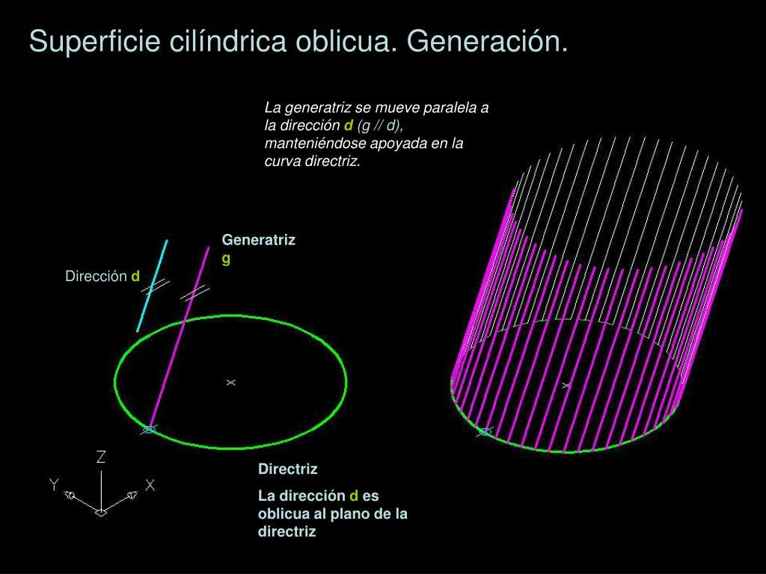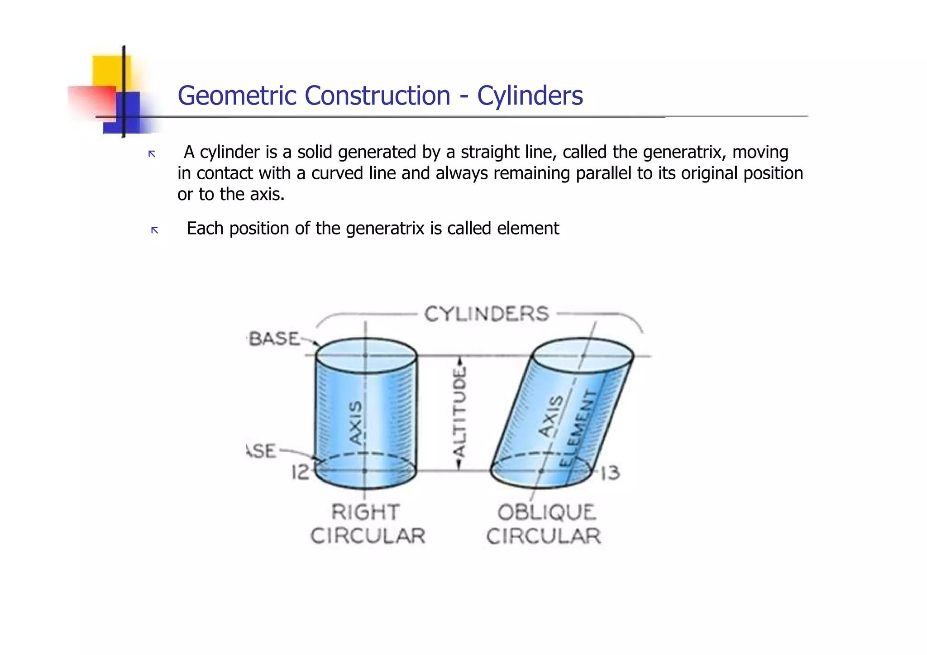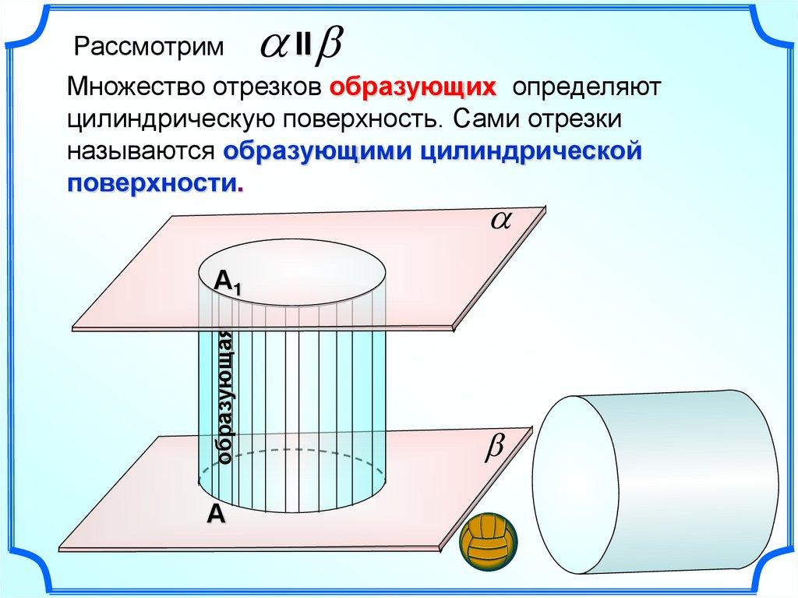
A Cylindrical Straight-Line Generator is a straight line that moves parallel to a fixed direction while continuously intersecting a guiding curve called the directrix.
Its successive positions form a cylindrical surface.
Characteristics:
- All generators are parallel to one another.
- The generator direction remains constant.
- Each generator intersects the directrix.
- The directrix determines the cross-sectional shape of the cylindrical surface.
Examples:
- Right Circular Cylinder.
- Oblique Circular Cylinder.
- Elliptical Cylinder.
- Prismatic Surface.

Conical Straight-Line Generator
# Source: AI Source: Provided by: [Data Path: Persons Table -> ID Column: 1, Name_En Column: Motasem Essam] -> From: [ChatGPT] on [7/25/2026]
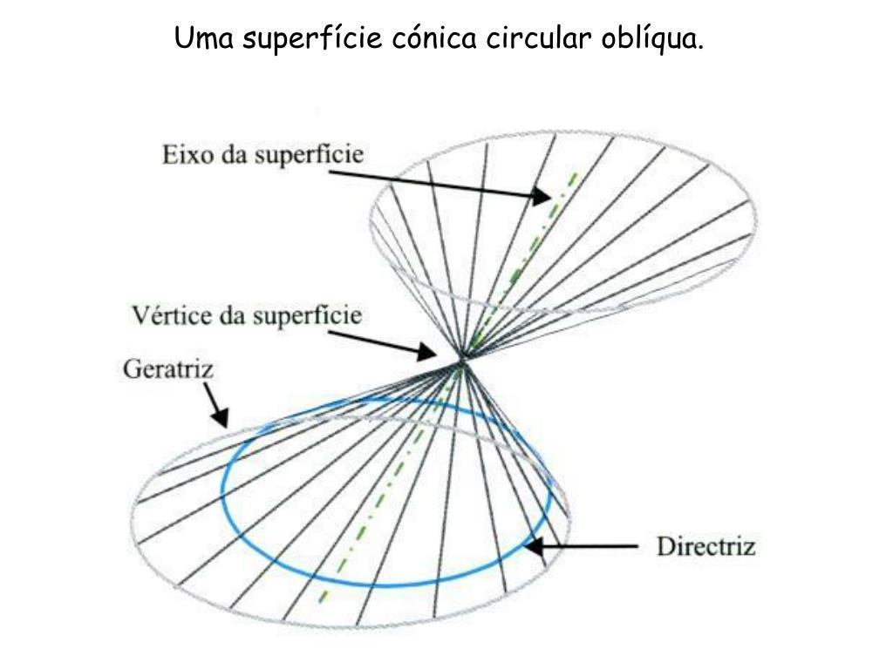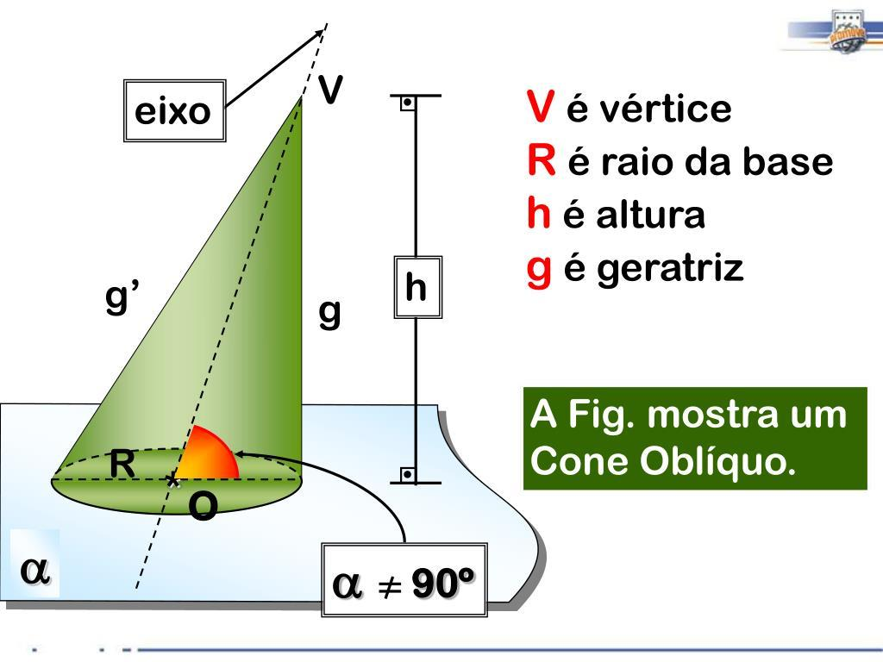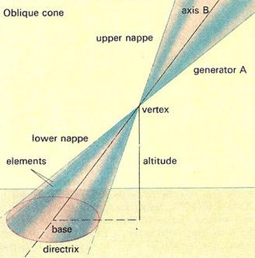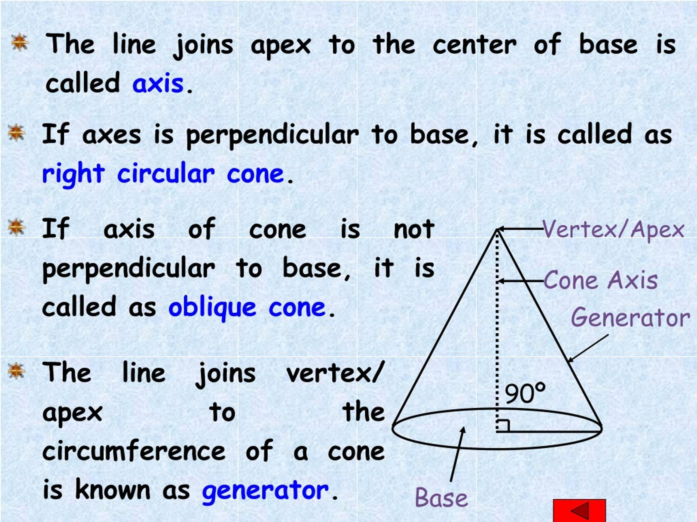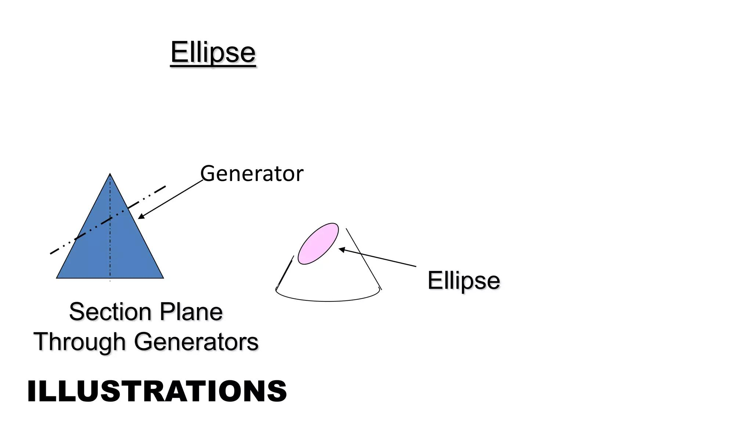
A Conical Straight-Line Generator is a straight line that passes through a fixed point called the vertex while its other point moves along a guiding curve called the directrix.
Its successive positions form a conical surface.
Characteristics:
- All generators pass through a common vertex.
- One endpoint remains fixed at the vertex.
- The other endpoint follows the directrix.
- The generator direction changes as the line moves around the directrix.
Examples:
- Right Circular Cone.
- Oblique Circular Cone.
- Elliptical Cone.
- Pyramidal Surface.

General Ruled-Surface Generator
# Source: AI Source: Provided by: [Data Path: Persons Table -> ID Column: 1, Name_En Column: Motasem Essam] -> From: [ChatGPT] on [7/25/2026]
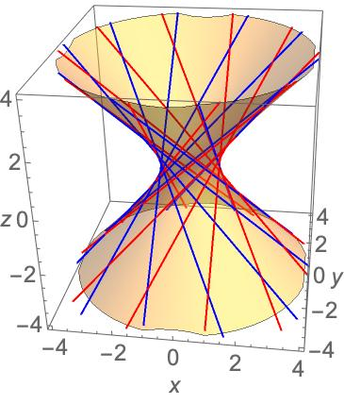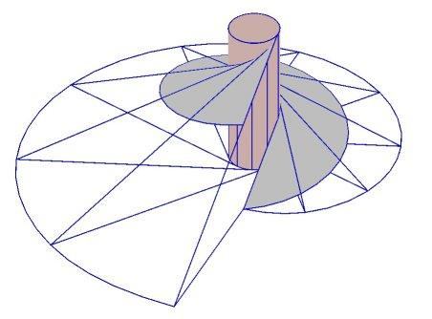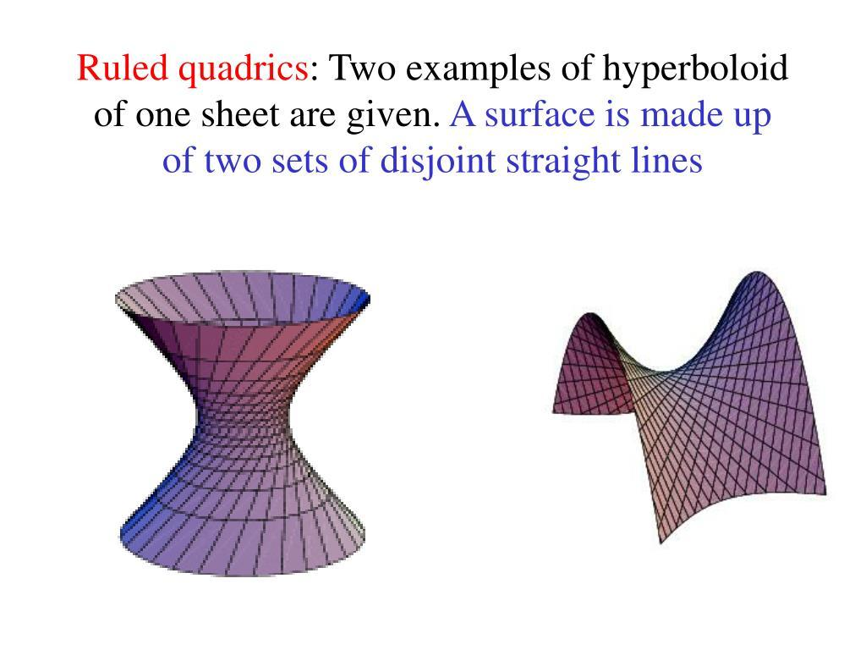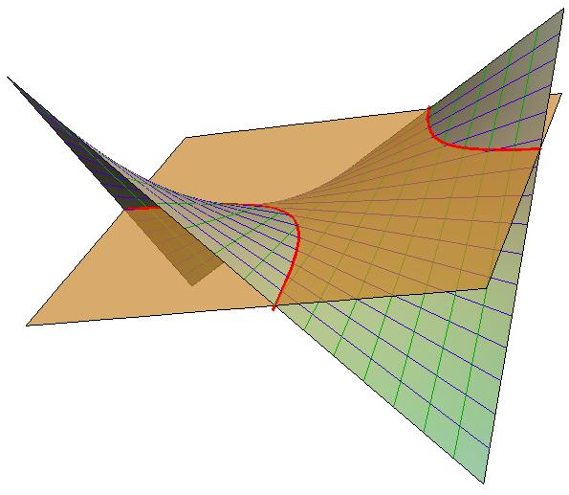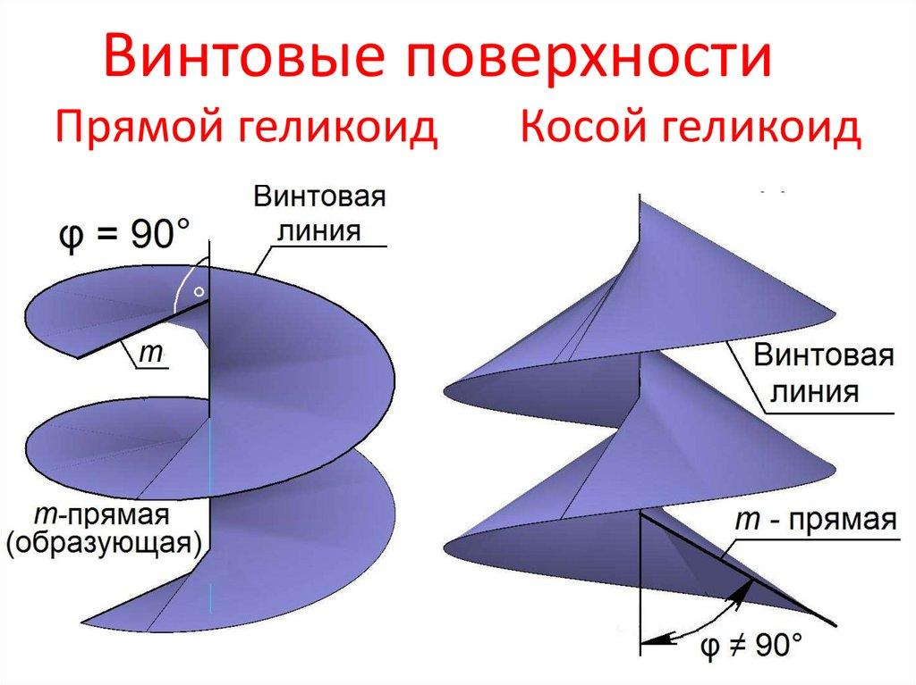
A General Ruled-Surface Generator is a straight line that moves according to a more general spatial rule, without necessarily remaining parallel to other generators or passing through one fixed vertex.
Its successive positions form a ruled surface.
Examples:
- Hyperbolic Paraboloid: Contains two distinct families of straight-line generators.
- Hyperboloid of One Sheet: Contains two distinct families of straight-line generators.
- Helicoid: Generated by a straight line moving while rotating and translating along an axis.
- Conoid: A ruled surface whose generators satisfy specified geometric constraints.
These examples demonstrate that straight-line generators can produce complex curved surfaces, not just cylinders and cones.

Mathematical Representation
# Source: AI Source: Provided by: [Data Path: Persons Table -> ID Column: 1, Name_En Column: Motasem Essam] -> From: [ChatGPT] on [7/25/2026]
A straight-line generator can be represented using a point and a direction vector.

General Straight-Line Equation
# Source: AI Source: Provided by: [Data Path: Persons Table -> ID Column: 1, Name_En Column: Motasem Essam] -> From: [ChatGPT] on [7/25/2026]
Let:
- $A(u)$ be a point on the generating line.
- $d(u)$ be its direction vector.
- $v$ be a parameter representing the position along the line.
The generating line is:
$$\boxed{X(u,v)=A(u)+vd(u)}$$
In Cartesian coordinates:
$$x=x_{0}(u)+v d_{x}(u)$$
$$y=y_{0}(u)+v d_{y}(u)$$
$$z=z_{0}(u)+v d_{z}(u)$$
Here, $u$ identifies a particular generator, while $v$ identifies a point along that generator.

Cylindrical Generator Equation
# Source: AI Source: Provided by: [Data Path: Persons Table -> ID Column: 1, Name_En Column: Motasem Essam] -> From: [ChatGPT] on [7/25/2026]
For a cylindrical surface with a directrix $c(u)$ and a constant direction vector $d$:
$$\boxed{X(u,v)=c(u)+vd}$$
The direction vector remains constant for every generator.
For example, a right circular cylinder of radius $r$, with its axis along the $z$-axis:
$$x=rcosu$$
$$y=rsinu$$
$$z=v$$

Conical Generator Equation
# Source: AI Source: Provided by: [Data Path: Persons Table -> ID Column: 1, Name_En Column: Motasem Essam] -> From: [ChatGPT] on [7/25/2026]
For a conical surface with a fixed vertex $A$ and a directrix $c(u)$:
$$\boxed{X(u,v)=A+v(c(u)-A)}$$
The vertex remains fixed, while the direction of each generator depends on the selected point of the directrix.

Geometric Properties
# Source: AI Source: Provided by: [Data Path: Persons Table -> ID Column: 1, Name_En Column: Motasem Essam] -> From: [ChatGPT] on [7/25/2026]
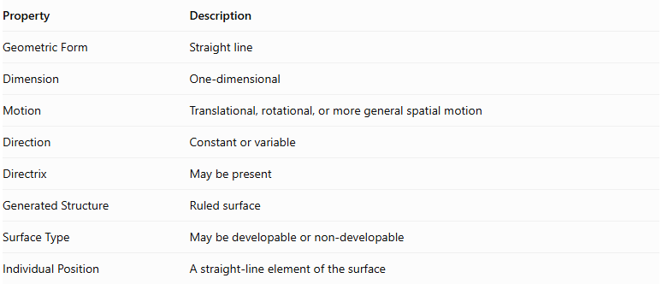
Property | Description
Geometric Form | Straight line
Dimension | One-dimensional
Motion | Translational, rotational, or more general spatial motion
Direction | Constant or variable
Directrix | May be present
Generated Structure | Ruled surface
Surface Type | May be developable or non-developable
Individual Position | A straight-line element of the surface

Ruled Surfaces and Their Generator Families
# Source: AI Source: Provided by: [Data Path: Persons Table -> ID Column: 1, Name_En Column: Motasem Essam] -> From: [ChatGPT] on [7/25/2026]
A ruled surface is classified according to the geometric relationship between its generators.

Developable Ruled Surfaces
# Source: AI Source: Provided by: [Data Path: Persons Table -> ID Column: 1, Name_En Column: Motasem Essam] -> From: [ChatGPT] on [7/25/2026]
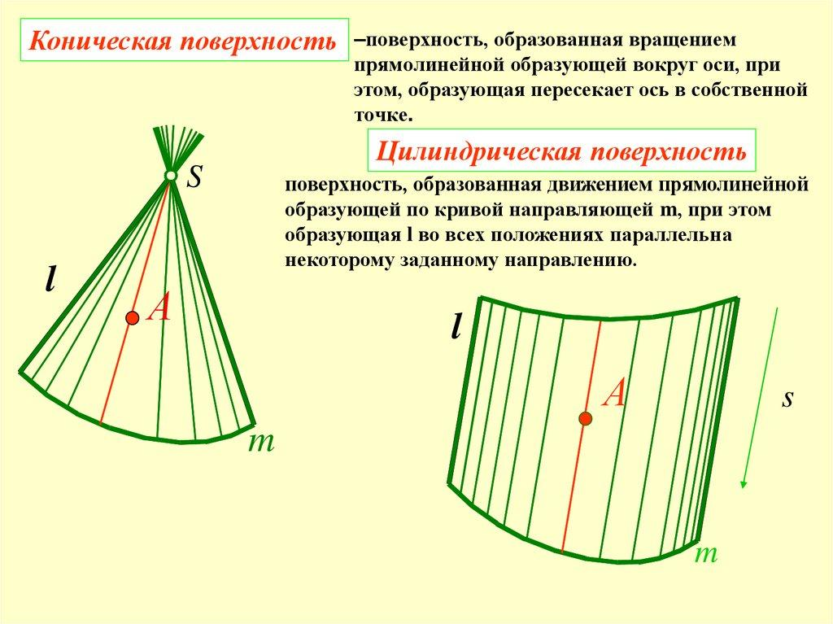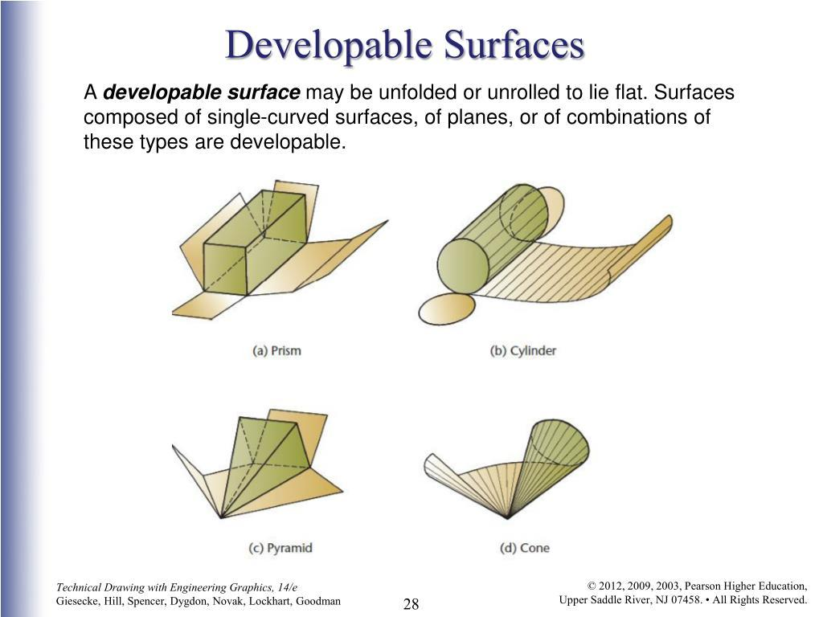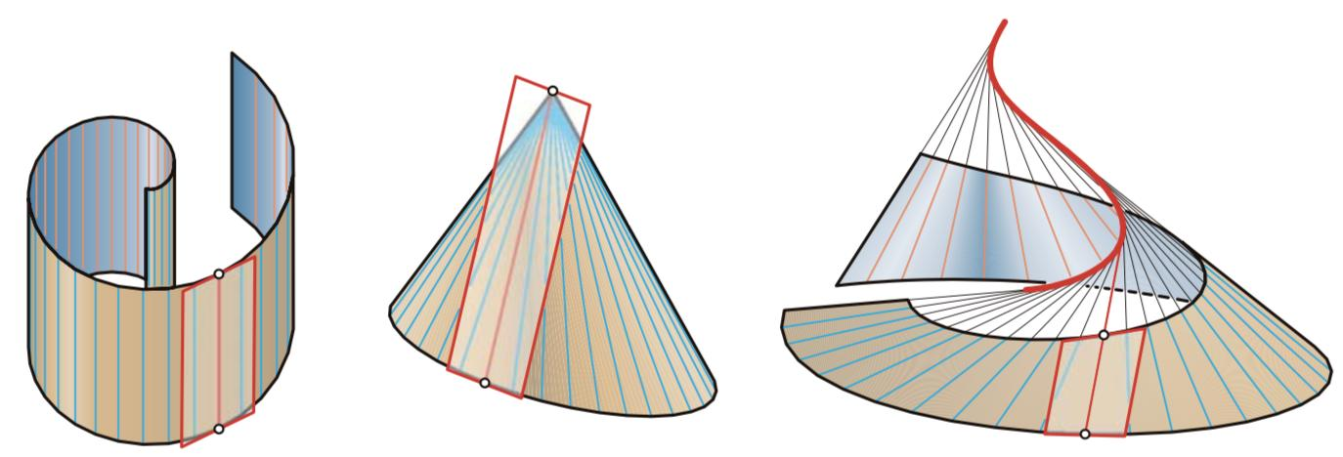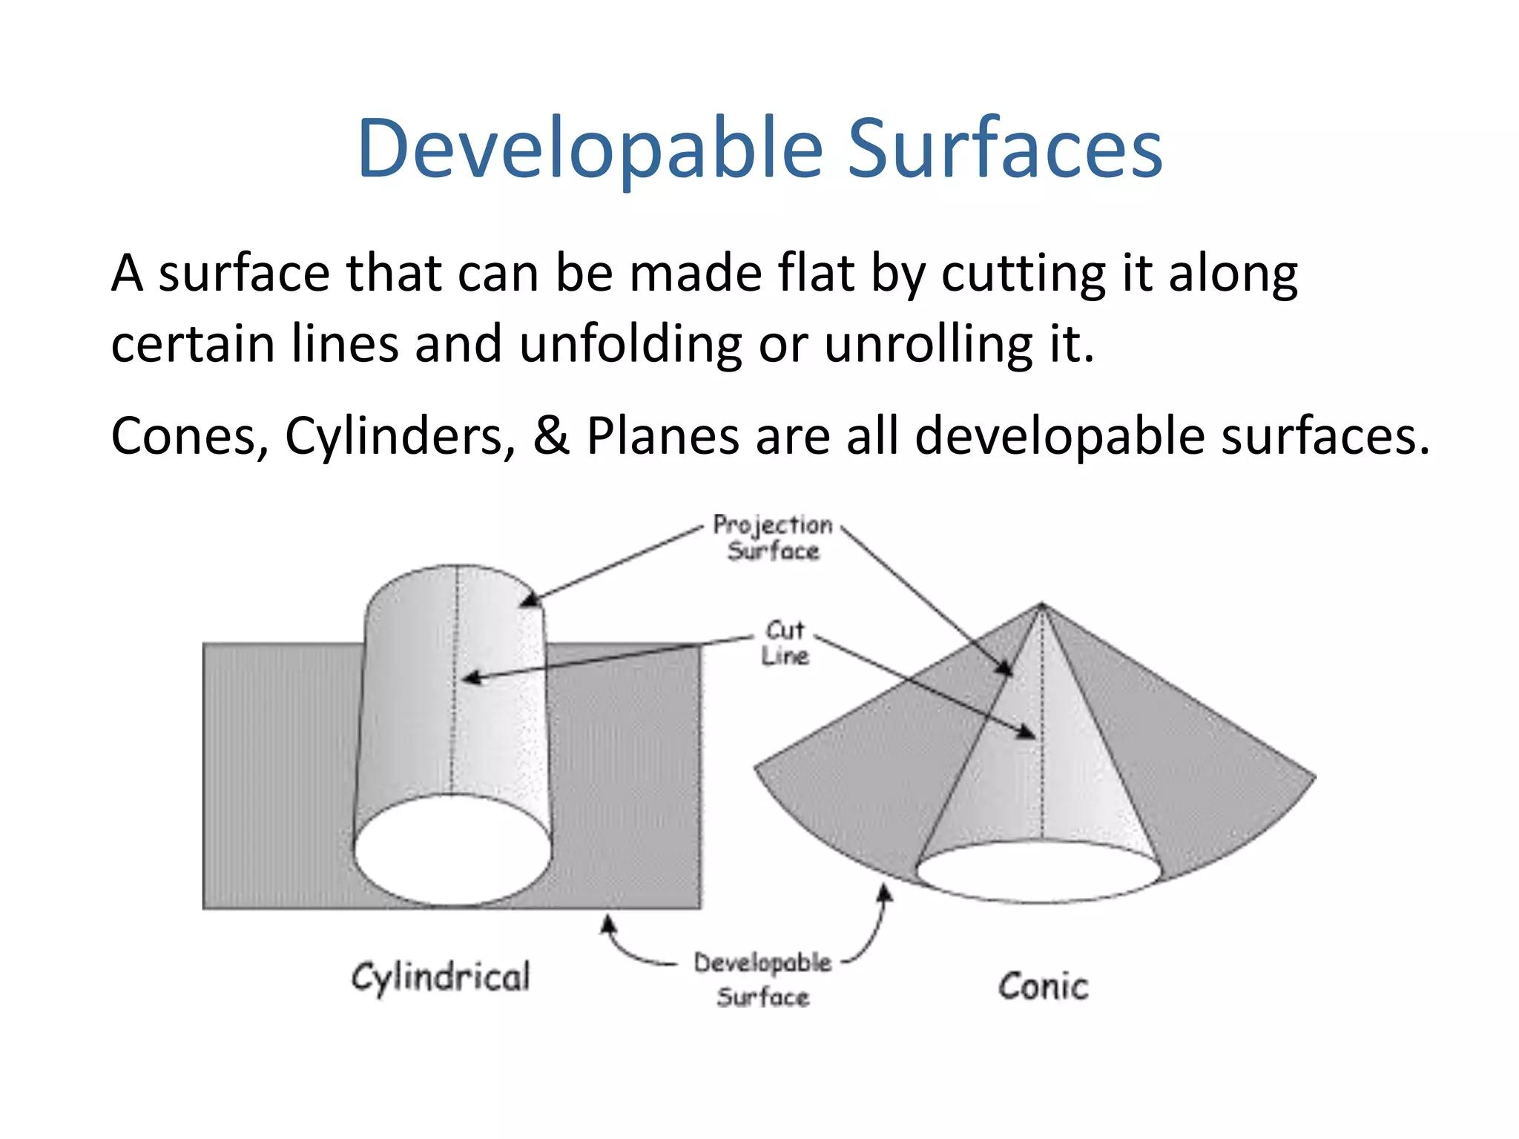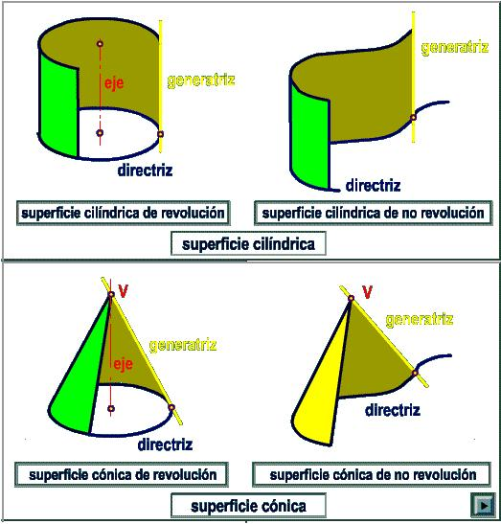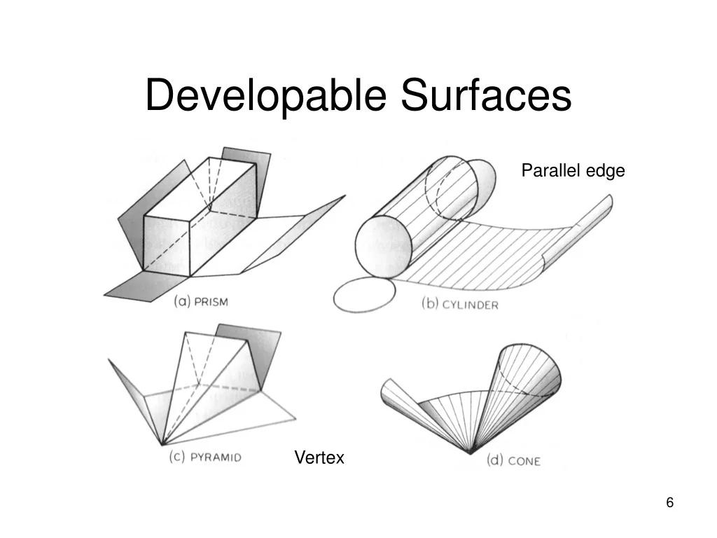
A Developable Ruled Surface is a ruled surface that can be flattened onto a plane without stretching or tearing.
Examples:
- Cylindrical Surface.
- Conical Surface.
- Tangent Developable Surface.

Non-Developable Ruled Surfaces
# Source: AI Source: Provided by: [Data Path: Persons Table -> ID Column: 1, Name_En Column: Motasem Essam] -> From: [ChatGPT] on [7/25/2026]
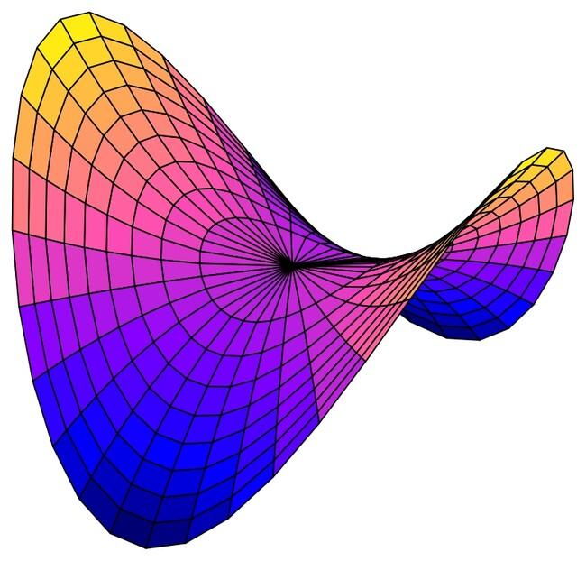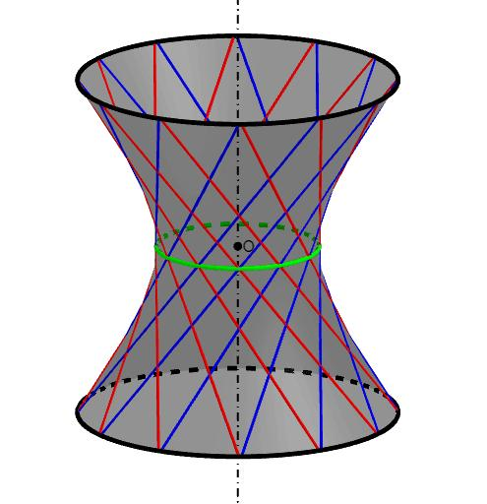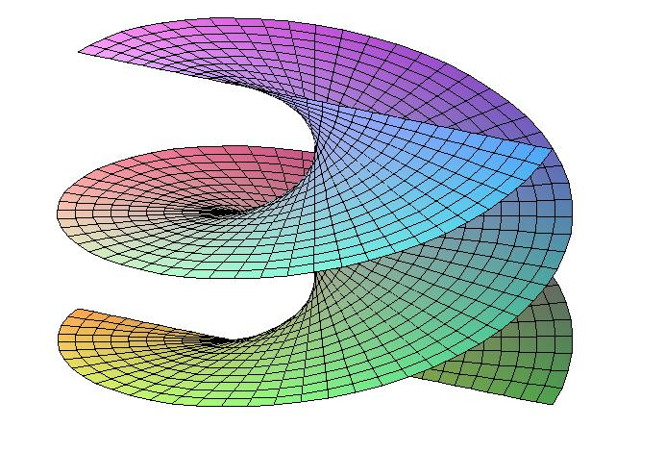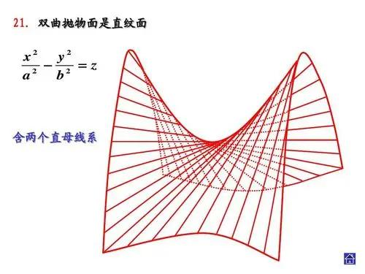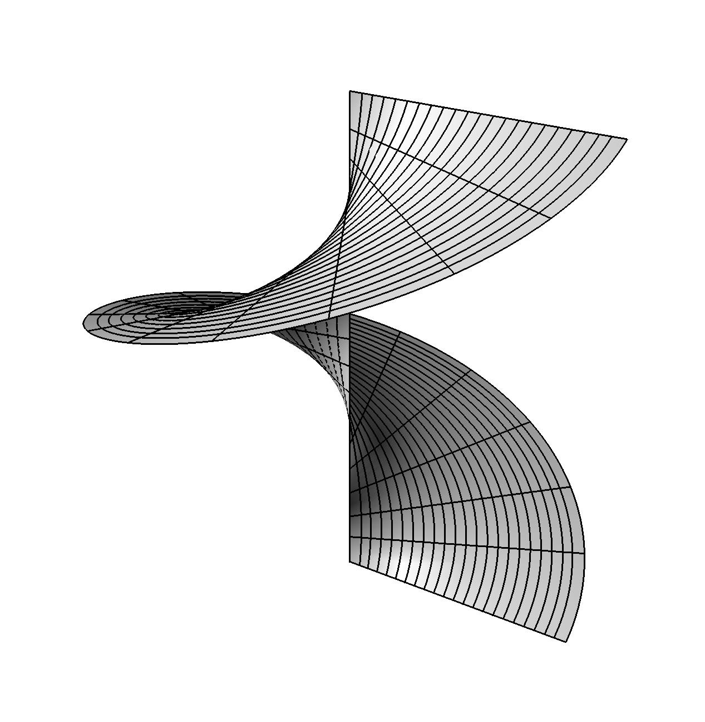
A Non-Developable Ruled Surface is a ruled surface that cannot be flattened onto a plane without distortion.
Examples:
- Hyperbolic Paraboloid.
- Hyperboloid of One Sheet.
- Helicoid.

Doubly Ruled Surfaces
# Source: AI Source: Provided by: [Data Path: Persons Table -> ID Column: 1, Name_En Column: Motasem Essam] -> From: [ChatGPT] on [7/25/2026]
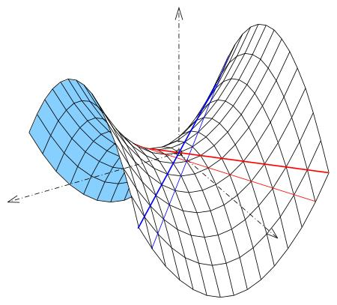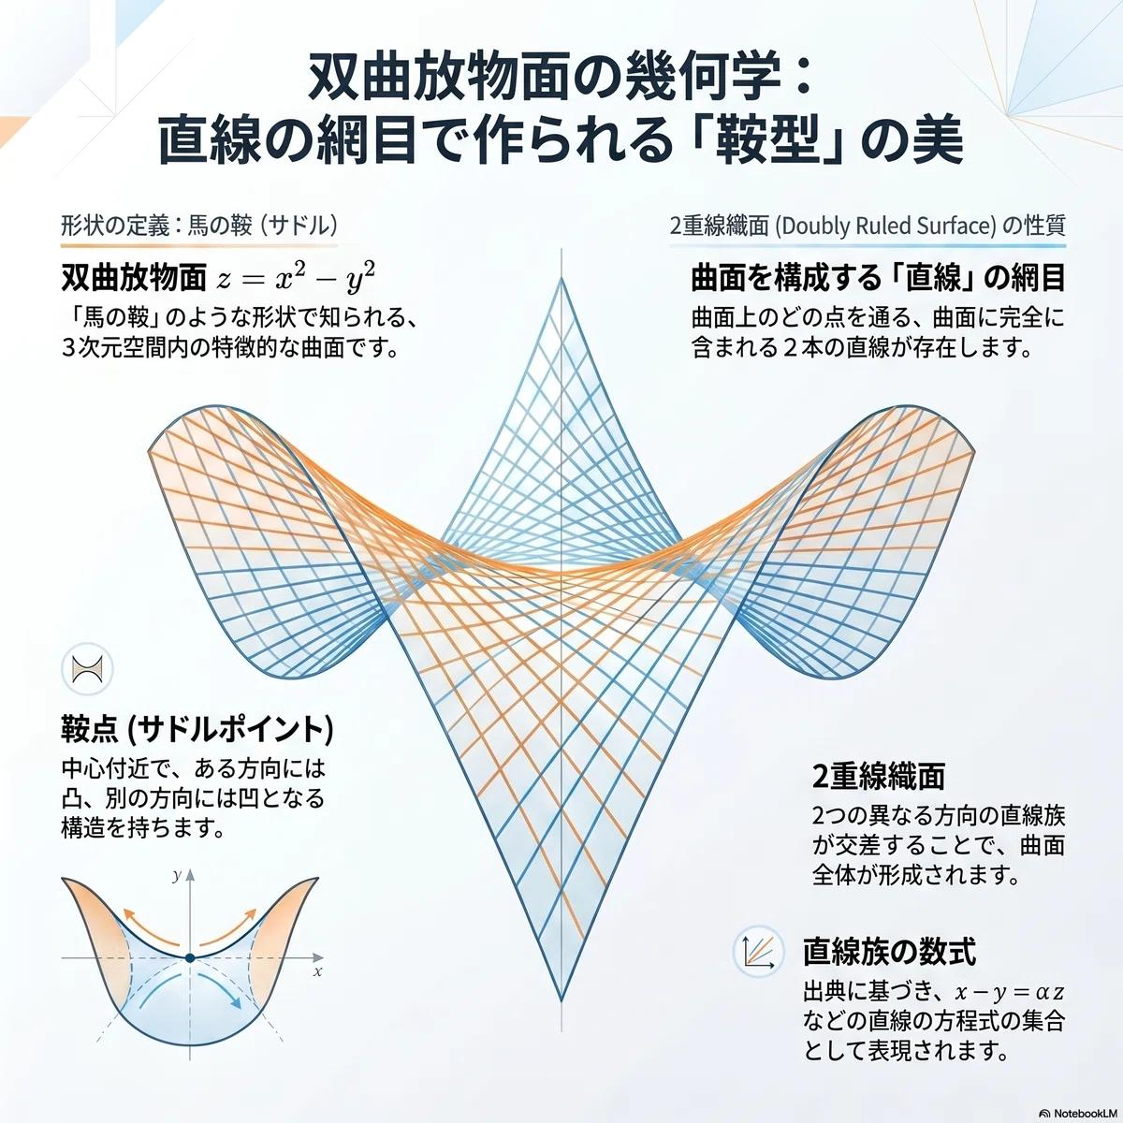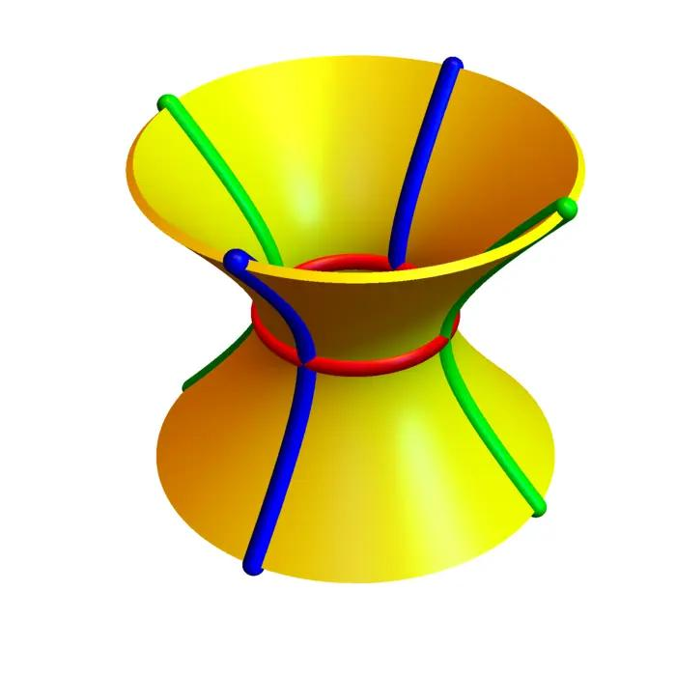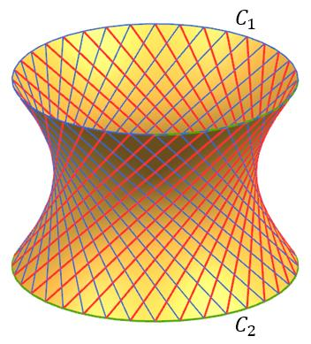
A Doubly Ruled Surface contains two distinct families of straight-line generators. Through a general point on such a surface, two different straight lines can be drawn that lie entirely on the surface.
Examples:
- Hyperbolic Paraboloid.
- Hyperboloid of One Sheet.
- Plane.

Comparison of Straight-Line Generator Types
# Source: AI Source: Provided by: [Data Path: Persons Table -> ID Column: 1, Name_En Column: Motasem Essam] -> From: [ChatGPT] on [7/25/2026]
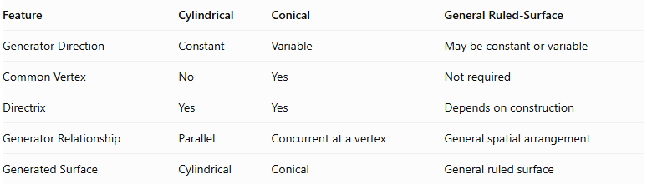
Feature | Cylindrical | Conical | General Ruled-Surface
Generator Direction | Constant | Variable | May be constant or variable
Common Vertex | No | Yes | Not required
Directrix | Yes | Yes | Depends on construction
Generator Relationship | Parallel | Concurrent at a vertex | General spatial arrangement
Generated Surface | Cylindrical | Conical | General ruled surface

Construction Process
# Source: AI Source: Provided by: [Data Path: Persons Table -> ID Column: 1, Name_En Column: Motasem Essam] -> From: [ChatGPT] on [7/25/2026]
- Define the Directrix: Specify the guiding curve, if the construction uses one.
- Define the Generator: Establish the straight line and its initial position.
- Specify the Motion: Determine how the line moves through space.
- Generate Successive Positions: Produce a continuous family of straight lines.
- Form the Surface: The union of these lines forms the resulting ruled surface.
- Define the Solid: If a solid is required, specify the boundaries and enclosed region.

Important Distinctions
# Source: AI Source: Provided by: [Data Path: Persons Table -> ID Column: 1, Name_En Column: Motasem Essam] -> From: [ChatGPT] on [7/25/2026]
- Generator vs. Directrix: The generator is the moving straight line; the directrix is the guiding curve.
- Generator vs. Axis: A generator is an actual straight-line element of a surface, whereas an axis is a reference line used to define orientation or rotation.
- Ruled Surface vs. Solid: A ruled surface is two-dimensional, even though it exists in three-dimensional space. A solid requires a three-dimensional enclosed region.
- Developable vs. Non-Developable: These classify ruled surfaces according to whether they can be flattened onto a plane without distortion; they are not separate types of generating lines.

Main Classification
# Source: AI Source: Provided by: [Data Path: Persons Table -> ID Column: 1, Name_En Column: Motasem Essam] -> From: [ChatGPT] on [7/25/2026]
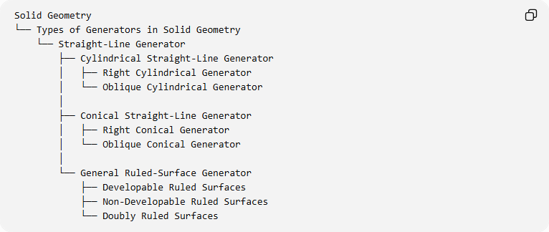
Solid Geometry
└── Types of Generators in Solid Geometry
└── Straight-Line Generator
├── Cylindrical Straight-Line Generator
│ ├── Right Cylindrical Generator
│ └── Oblique Cylindrical Generator
│
├── Conical Straight-Line Generator
│ ├── Right Conical Generator
│ └── Oblique Conical Generator
│
└── General Ruled-Surface Generator
├── Developable Ruled Surfaces
├── Non-Developable Ruled Surfaces
└── Doubly Ruled Surfaces
Classification note: The last three categories describe the resulting ruled surfaces rather than mutually exclusive types of generators. Doubly ruled surfaces can also be non-developable.

Key Points
# Source: AI Source: Provided by: [Data Path: Persons Table -> ID Column: 1, Name_En Column: Motasem Essam] -> From: [ChatGPT] on [7/25/2026]
- A straight-line generator is a moving straight line that generates a surface.
- A surface formed by straight-line generators is called a ruled surface.
- Cylindrical generators remain parallel to one another.
- Conical generators pass through a common vertex.
- General ruled-surface generators can follow more complex spatial paths.
- Hyperbolic paraboloids and one-sheet hyperboloids are examples of doubly ruled surfaces.
- Ruled surfaces can be developable or non-developable.

Conclusion
# Source: AI Source: Provided by: [Data Path: Persons Table -> ID Column: 1, Name_En Column: Motasem Essam] -> From: [ChatGPT] on [7/25/2026]
The Straight-Line Generator is a fundamental generating element in solid geometry. Its movement through space produces ruled surfaces, including cylindrical surfaces, conical surfaces, and more complex forms such as hyperbolic paraboloids and hyperboloids of one sheet.

